**VERMICOMPOSTING**

*Composting with worms!*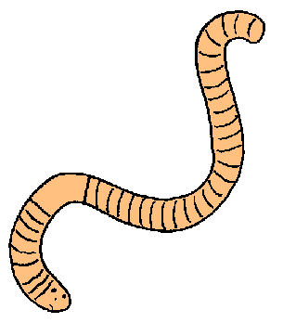

This is the home of your new pet Red Wiggler worms. They will recycle your organic kitchen waste. You only need to feed them a little bit each day. Please post this near the bin and follow the steps below.

**You will need:**

1. **Bin**

* BUY: You can buy kit or a stand-alone bin online (e.g. kidsgardening.org)
* MAKE: Drilling holes in the lid and along the top of an opaque plastic storage bin (not clear)

1. **Worms (Red Wigglers)**

* A good place to order worms is Uncle Jim’s Worm Farm (www.unclejimswormfarm.com)
* You need about 1,000 worms (about 1 pound) to get off to a good start.

1. **Bedding**

* BUY: Quar (Shredded coconut shells) make a nice even bedding
* MAKE: Shredded newspaper and dried leaves is a good addition

| **DO COMPOST:**   * Raw fruits and veggies * Coffee grinds & filter * Crushed egg shells * Leaves * Tea bags & leaves | **DO NOT COMPOST:**   * Meat or fish * Dairy products (milk, cheese) * Oils * Cooked foods * Citrus fruits & rinds |
| --- | --- |

**Basic Worm Care:**

* They may be a bit stressed after traveling, so don’t be alarmed if they try to climb out of the bin for the first week or so. Make sure they are damp, have plenty of bedding (newspaper, kraft paper, dried leaves) and some food.
* Feed your worms about once a week. Break up food into smaller pieces so it’s easier for worms to eat. Stay away from too many orange peels as the citric acid can disturb the worms. Do not put anything rotten or fermenting into your bin.
* Keep your bin moist, but not too wet. Bedding should feel damp, like a wrung out sponge. If the bin is too dry, spray with water. If bedding is too wet, add shredded paper. Overly wet bins may also be an indication of over-feeding.
* Regularly add bedding (every few weeks).
* Separate out castings (compost) after about 6 months. Older/more mature kids can be a great help, by having every student pull out the worms from the composted material and add back into the bin with fresh bedding.
* Spread the composted material in garden bed or potted plants for added nutrients